**Online Marketing and SEO Plan**

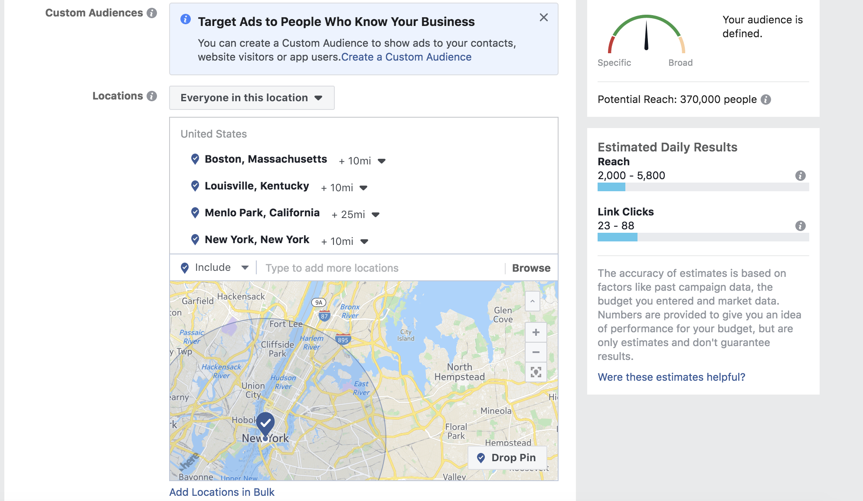

I chose my audience in specific cities because I want my site to gain attraction and clicks in areas where I know I could find and or would want to work. I chose big cities and areas where I knew there was a good tech scene because I am trying to market myself and my capabilities to employers.

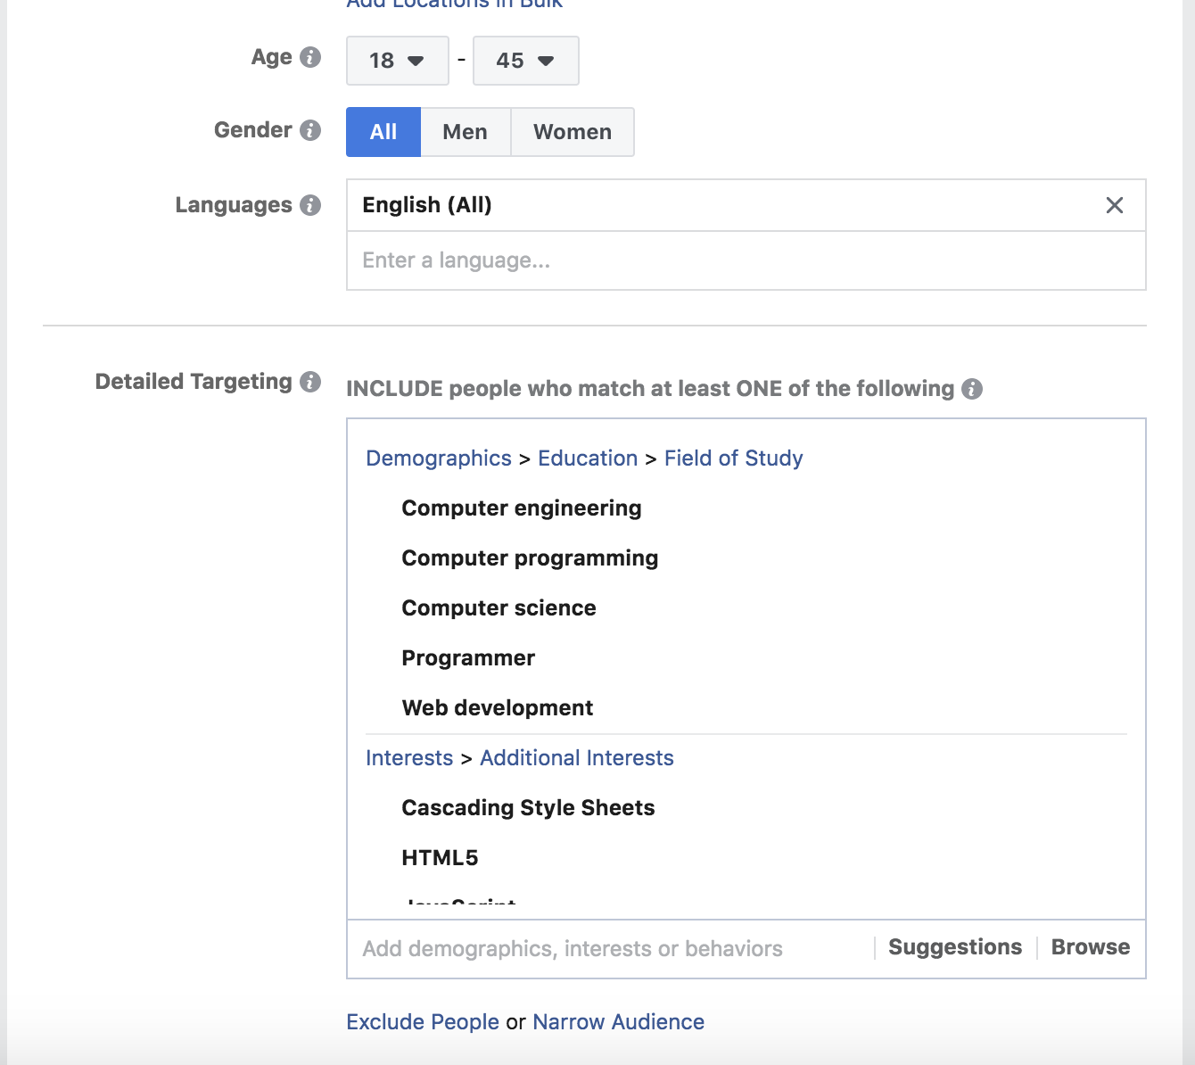

In addition, I made the age range people in college through the typical age of the working American. I figured this would be an acceptable demographic because sometime companies will use other students to recruit, and other times the older employers will do the recruiting, so I covered all my bases. Finally, I chose to display my website to both men and women because every day the number of women in tech increases and I want to prove myself.

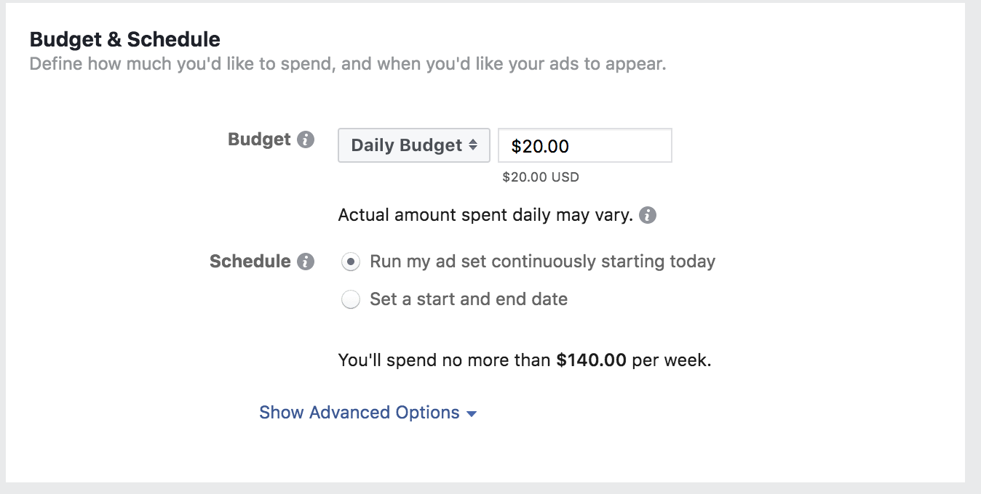Lastly, because I am a broke college student I cannot afford to spend more than 20 dollars a day on the campaign. I will go broke spending that much anyways, but hopefully before I end up broke someone will have seen my site and I will have found a job. However, if I am imagining that money is no issue $20 a day seems like a fair amount to promote myself, at least for the present time, because I do not have too much experience so I may not even be of use to most companies yet.